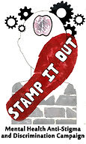
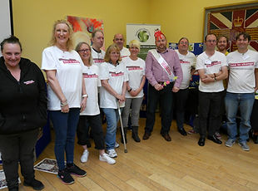
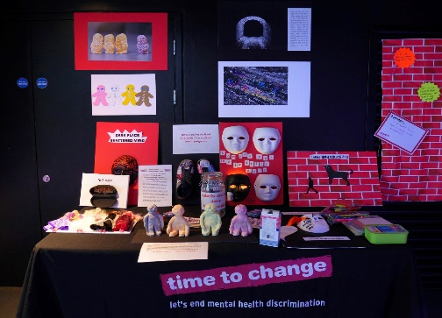

“Event in a Box” Contents choices

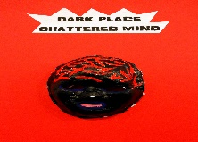
A1 A shattered Mind

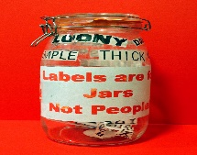

A2 Labels are for jars not people (large Kilner jar)

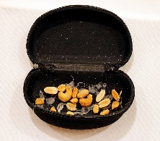

A3 Nutcase

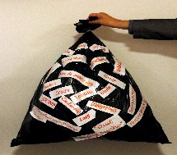

A4 Bin liner/ band/labels’ you’ll need newspaper to fill
(Do not return)

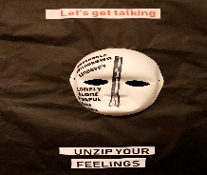

A5 My Mask

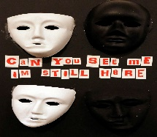

A6 can you see me

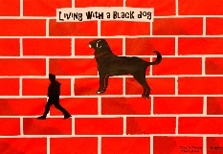

A7 Living with a black dog

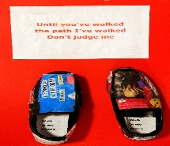

A8 Until you’ve walked my shoes

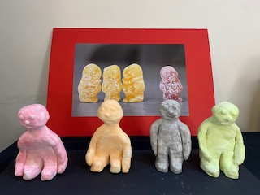
A9 1 in 4 Jellies clay models (4 pieces)

A10 Darkness at the end of the tunnel photo

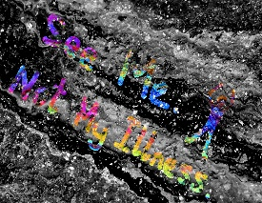
A11 see me not my illness photo

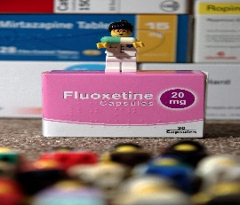

A12 Bow to your new god photo

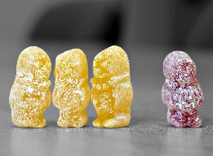

A13 1 in 4 Jelly photo

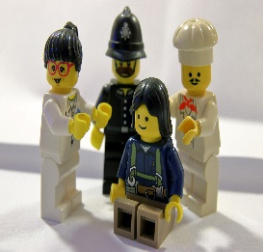

A14 1 in 4 Lego Photo

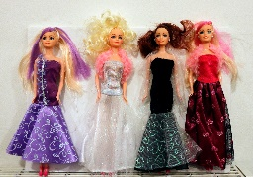

A15 Crazy Girls “which one am I?”

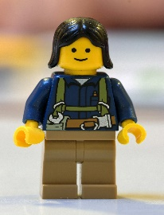
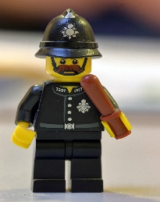
A16 1 in 4 Lego people

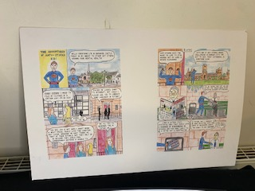

A17 Anti stigma Kid first comic

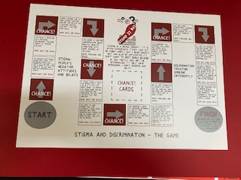

A18 Anti stigma boardgame (includes 2 large dice and cards)

# FAMOUS COLLECTION-20/21

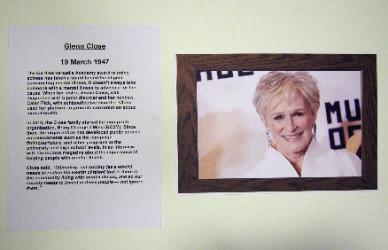
#FAMOUS COLLECTION Woman

#FW1 Famous-Glenn Close

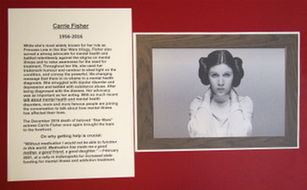

#FW2 Famous -Carrie Fisher

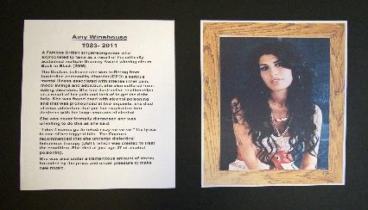

#FW3 Famous Amy Winehouse

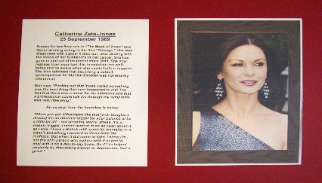

#FW4 Famous Catherine Zeta-Jones

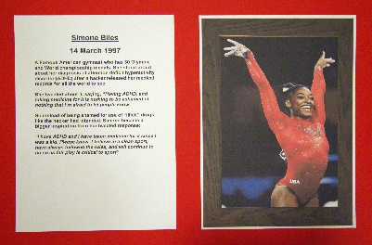

#FW5 Famous -Simone Biles

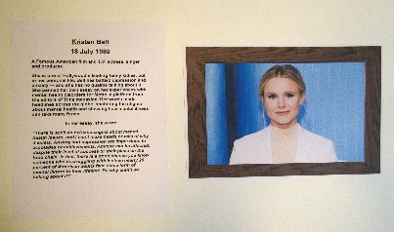

# FW6 Famous- Kristen Bell

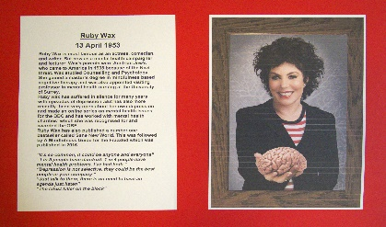

# FW7 Famous- Ruby Wax

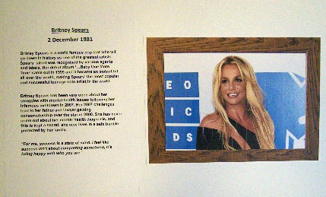

# FW8 Famous-Britney Spears

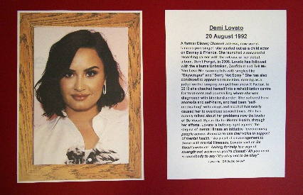

# FW9 Famous- Demi Lovato

#FAMOUS COLLECTION MEN

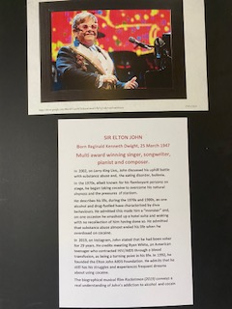

#FM1 Famous-Sir Elton John

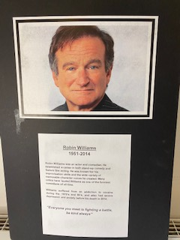

#FM2 Famous- Robin Williams

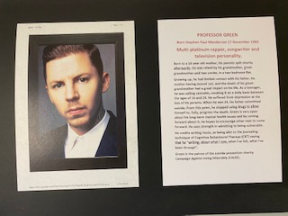

# FM3 Famous-Professor Green

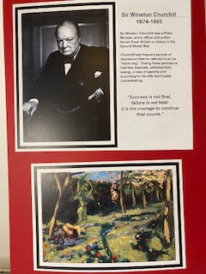

#FM4 Famous- Sir Winston Churchill

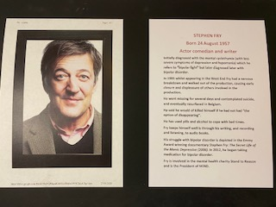

#FM5 Famous- Stephen Fry

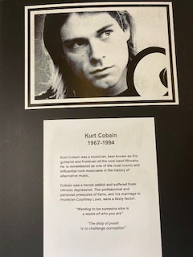

#FM6 Famous- Kurt Cobain

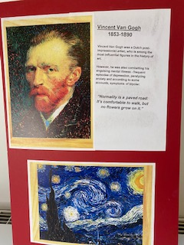

# FM7 Famous- Vincent-Van Gogh

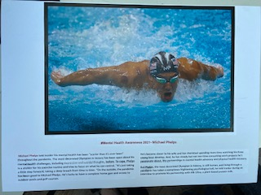

# FM8 Famous- Michel Phelps

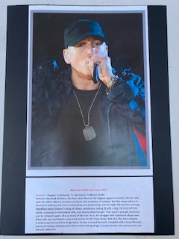

#FM9 Famous- Eminem

KNOW YOUR FACTS-Mental Health Awareness 2021(MHA)
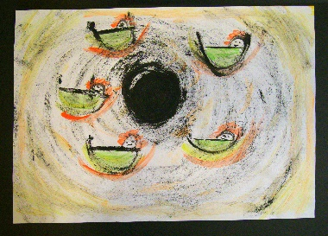

MHA 1-Post-Natal Depression

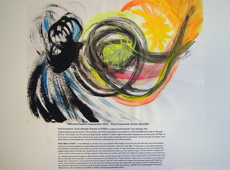

MHA2-PTSD -Post-traumatic stress disorder

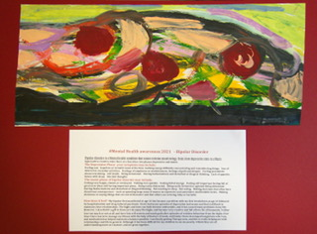

MHA3 Bipolar disorder

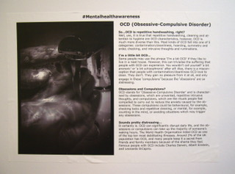

MHA4 -obsessive compulsive disorder (OCD)

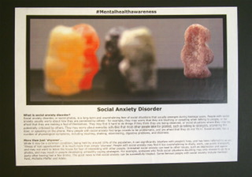

MHA5- Social anxiety

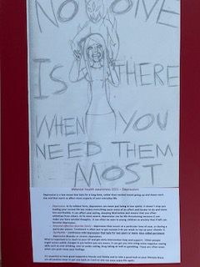

MHA6- Depression

MHA7-Generalized anxiety

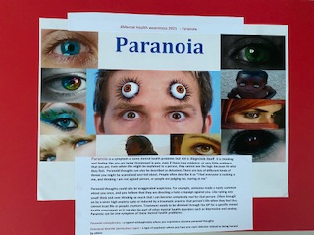

MHA8 -Paranoia

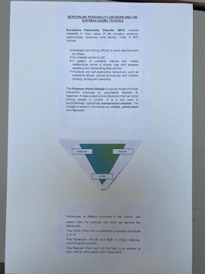

MHA9- Personality disorders BPD Borderline personality disorder

Box contents -How to create your own anti stigma event from
“Event Pop up box”
1-Box (35 litre) contains: -
Red tablecloth –8x4 size to cover your table/ desk. Fold accordingly to fit the area.
“Art Shoes “ (to sit on board for “walk in my shoes art”)
“Clay Jellies” -PLEASE unwrap carefully and re wrap in bubble wrap (to sit on black card with laminated writing separate piece)
Pass the parcel – create a conversation kit. Either put together yourself from typed questions, and newspaper/ old magazines ( to recycle) then wrap each layer with a sweet and question on each layer. Suggested for groups of 4-6 people.
Pledge Wall Brick by Brick-All You need is coloured felt tips/ or black marker pens/post it notes/speech bubbles/ blue tac (can easily be made by cutting up pieces of paper). Redbrick anti-stigma wall can be made and printed onto A3 paper x4 if you wish large (cello tape together from behind). After each conversation as participants to say how they could challenge stigma within workplace/ community/ local area/between friends.
USB STICK-Ask for USB stick (should be in your box in tiny wooden box) with all the documents you need for your event)
Tin time for conversations- “its time to talk” 4 tins for public to pick out of to have a conversation. (Ask for labels and contents labels and create your own from cleaned out baked bean tins)
Art currently -45 pieces can be spread between the 4 boxes. Portfolio cases x4
White masks-Add x2 Masks can be added to pull out 3-fold screen can add small battery lights inside with the idea of “can you see me”
2-Leaflets and other contents in the kit
1-Quiz-SIO x 4 quizzes A4 copies
2-SIO flyer-Current SIO 2-page flyer
3-3-fold leaflet “Did you know 1 in 4” x20
4-A5 Anti-stigma Kid magazines/ any updated anti stigma stories
5-Face stickers- Time to change face stickers
6-Parrtner Leaflets-Other partners info/ leaflets e.g., Waddington/Alliance partners?
7-signposting information-Current County dirham information for support. in posting-Referral partners and signposting information
8-Bin liner (black) stigmatising names/ bin liner/ elastic band; all you need is old newspapers and shredded paper to fill the black pigstick on the labels and its already.
9-“Take 5 conversation starter” Click clack a conversation starter-time to change, to use and start conversations. (They are flat, ready to fold, in a large white envelope) make up x 4 for your event.
10- Time to change conversation starters- credit card size small wallet size 3-fold leaflet. (Blue and red)
11- Anti stigma selfie frame-use for participants to post on your/ their social media platforms/ share social media / post on your company website/emails/ charity/ community Facebook/ Instagram/ Twitter etc.
Send to us so we can post on Facebook/Instagram /twitter
Stamp it out country Durham Facebook-posts Facebook
Stamp it out county Durham@_stampoutstigma/Twitter
Stamp it out county Durham @stampitout_codurham*Instagram
12-Online to our web:- https://www.stampitoutcountydurham.co.uk/
3-Hard Art in A3 portfolio case- choose from 45 art pieces and we can pick and mix to your setting (or just ask for a mixed set) see list earlier in this document. Art 1-9, #famous 1-9x2, #mental health awareness 2021.
4-Tabletop 3-fold display stand (in a bag easy to unfold and assemble)-Screens come already complete with SIO display items on just add masks/ your own contacts /signposting within your community/school/ business/ charity/organisation or any current new information we might of put on your USB stick.
5-Stamp it out Pop up display poster-simply remove form its bag and pull up as a lovely visual to attract people to your event. in black bag)

